**Object Oriented Programming**

**CSC-241**

LAB - 5

Name: Afnan Malik

Registration No: SP20-BSE-003

Section: 3A

Submitted To: Sir Mukhtar Azeem

SOURCE CODE

HOME ASSIGNMENT -1

/*

* To change this license header, choose License Headers in Project Properties.

* To change this template file, choose Tools | Templates

* and open the template in the editor.

*/

package L4HA1;

/**

*

* @author Khurshid Awan

*/

import java.util.Scanner;

public class Fraction {

private int numerator;

private int denominator;

public Fraction(int n, int d) /* Creating argumented constructor */

{

numerator = n;

denominator = d;

}

public void setNumerator(int n) /* creating set method to set the private variable numberator */

{

numerator = n;

}

public void setDenominator(int d) /* creating set method to set the private variable denominator */

{

denominator = d;

}

public void displayFraction() /* display method according to condition */

{

System.out.print(numerator + "/" + denominator);

}

public boolean equals(Fraction other) /* equal method to check whether the fraction is equal or not */

{

int num1, num2;

int num3, num4;

int num5 = 1;

for (int i = 2; i <= Math.min(numerator, denominator); i++)

{

if (numerator % i == 0 && denominator % i == 0)

num5 = i;

}

num1 = numerator / num5;

num2 = denominator / num5;

int otherGcf = 1;

for (int i = 2; i <= Math.min(other.numerator, other.denominator); i++)

{

if (other.numerator % i == 0 && other.denominator % i == 0)

otherGcf = i;

}

num3 = other.numerator / otherGcf;

num4 = other.denominator / otherGcf;

return (num1 == num3 && num2 == num4);

}

}

Screen Shot of class Fraction

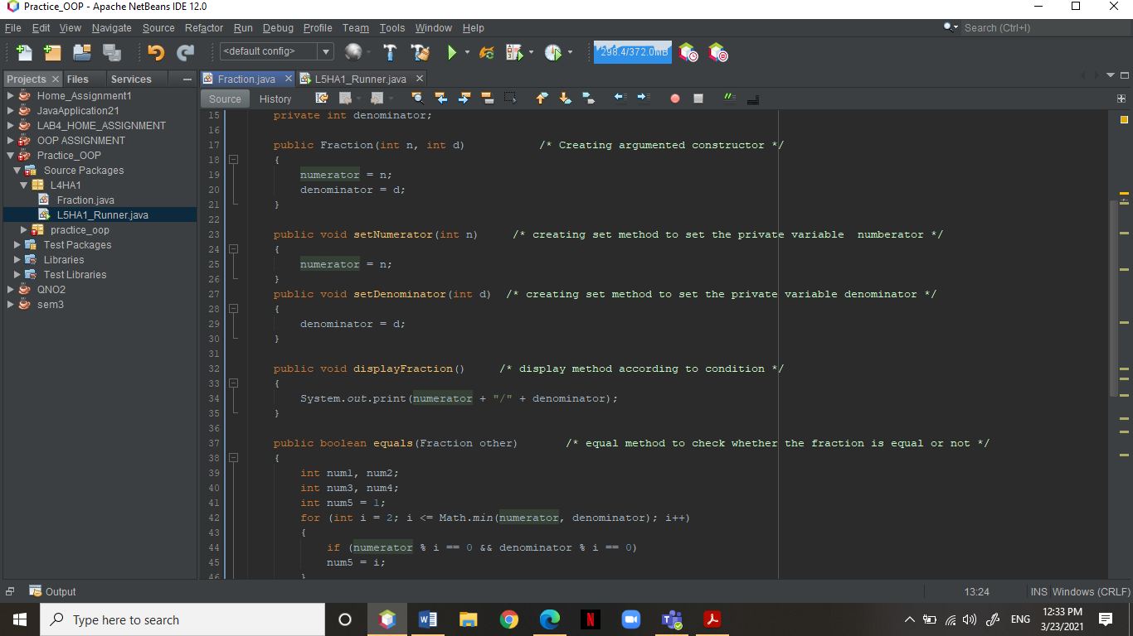

Runner

/*

* To change this license header, choose License Headers in Project Properties.

* To change this template file, choose Tools | Templates

* and open the template in the editor.

*/

package L4HA1;

/**

*

* @author Khurshid Awan

*/

import java.util.Scanner;

public class L5HA1_Runner

{

public static void main(String[]args)

{

Scanner input = new Scanner(System.in);

int numerator, denominator;

System.out.print(" Enter First Fraction's Numerator: ");

numerator = input.nextInt();

System.out.print(" Enter First Fraction's Denominator: ");

denominator = input.nextInt();

Fraction fraction = new Fraction(numerator, denominator);

System.out.print("Enter Secnod numerator: ");

int otherNumerator = input.nextInt();

System.out.print("Enter Secnod denominator: ");

int otherDenominator = input.nextInt();

Fraction otherFraction = new Fraction(otherNumerator, otherDenominator);

if (fraction.equals(otherFraction))

{

fraction.displayFraction();

System.out.print(" is equal to ");

otherFraction.displayFraction();

System.out.println(" True");

}

else

{

fraction.displayFraction();

System.out.print(" is not equal to ");

otherFraction.displayFraction();

System.out.println(" False ");

}

}

}

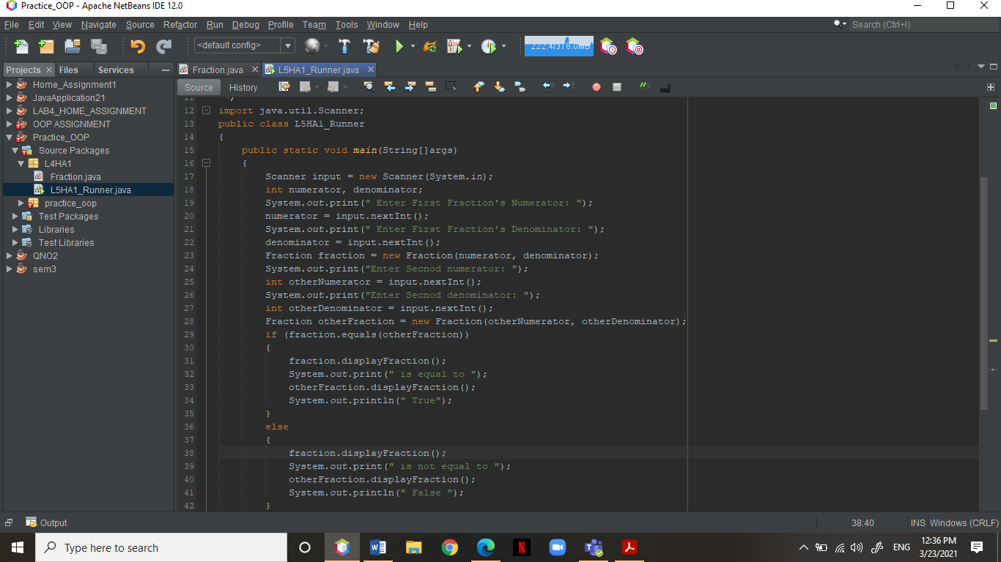Screen Shot of Runner

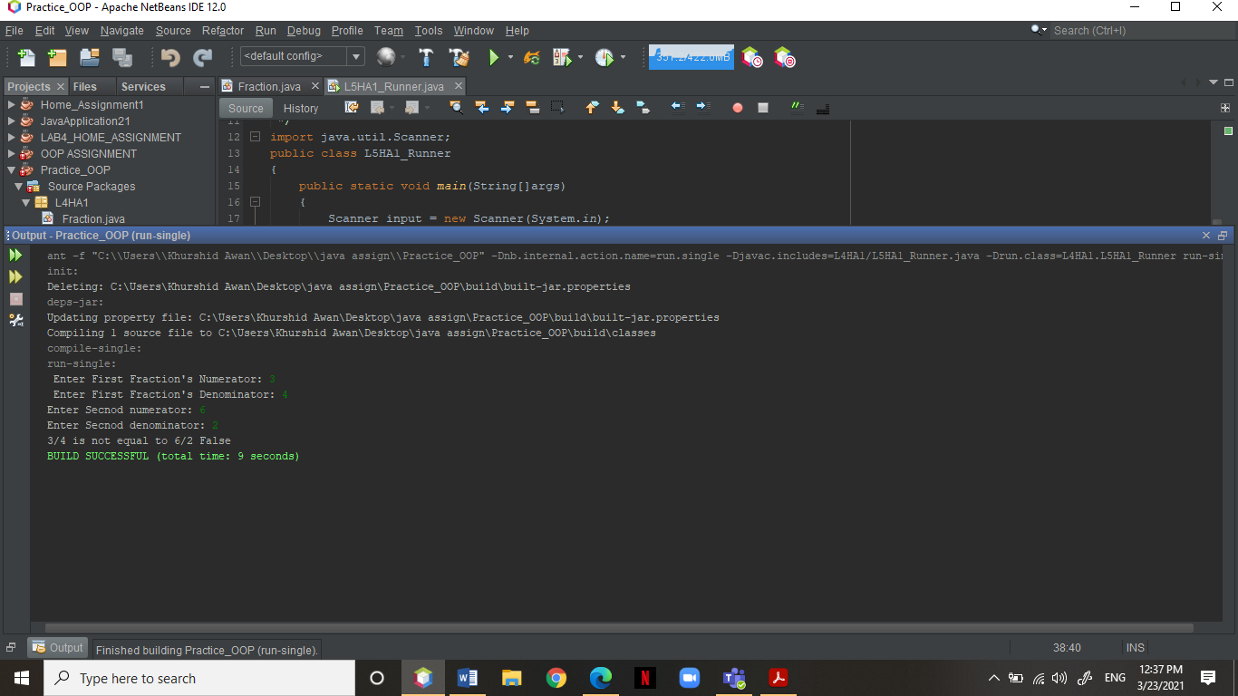OUTPUT SCREEN SHOT

GITHUB RESPORAITORY LINK